Power team’s programming needs

11/9/2017

Overview of power system:

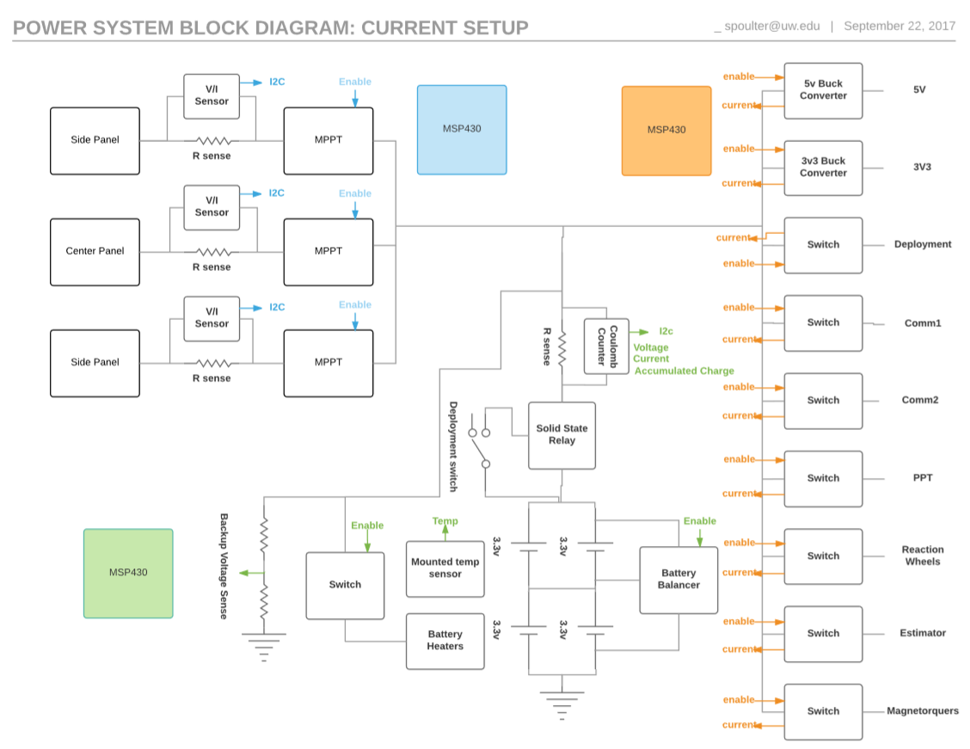

Figure1: Signals to and from each of the MSP430’s to the components in the power system. Blue represents the MSP430’s on the Power generation board. Green represents the MSP on the battery board. Orange represents the MSP430 on the distribution board.

The only boards we currently have built are the distribution board and the power generation board. So we will focus on those two in the immediate future.

Distribution board: The distribution board’s MSP is arguably the closest thing to a central brain in the satellite. It manages the states of the satellite by switching subsystems on and off, responding to under-voltage events, and it’s the microcontroller that resets all others.

* Distribution switches: (<http://www.ti.com/lit/ds/symlink/tps24750.pdf> ) The distribution switches turn power on and off to specific subsystems or “power domains” of the satellite and monitors how much current is going through each switch
  + Goals: The programming to get these “functioning” is minimal because there are only two things the MSP physically controls (enabling switches, reading current) but there’ll be lots of tests to write to fully characterize the switches behavior. Ex: Testing the accuracy of the current measurement vs actual current.
  + Programing needs.
    - Enable/disable through MSP
    - Read Voltage on $I_{MON}$ pin with the MSP (to measure current.)
  + Existing progress:
    - Switches can be enabled through external 3V3 signal but only when the MSP is off the board. Otherwise the protection diodes sink current through the enable pins.
    - Voltage on the $I_{MON}$ pin measures a voltage which is close to the correct value, accuracy is uncertain.

Power gen board: The power gen board is the input for the solar panels, it measures the voltage and current from the solar panels while a Power tracker holds the solar panels at an optimum voltage, by varying the input resistance that the solar panels see. Additionally, the power trackers are a step down converter that reduces the input voltage to the battery’s voltage while raising the current. The solar panels are “turned off” by turning off the power trackers.

* INA219 current monitors: (<http://www.ti.com/lit/ds/symlink/ina219.pdf> ) The INA measures the voltage and current from the solar panels into the satellite. It does this by measuring the voltage drop across a shunt resistor, which is a very low value resistor (.002 ohms)
  + Programming needs:
    - Wrapper that implements needed features.
  + Existing progress:
    - Found an Adafruit library to use with Arduino. The library has been used to talk to the INA which does respond to its address. However the INA is not calibrated for the chosen shunt resistor, so it reads incorrect values for voltage and current.
* Power tracker: (<http://cds.linear.com/docs/en/datasheet/3652fe.pdf>) The Power tracker (LT3652) is a buck converter (converts from high voltage to low voltage) that controls the voltage of the solar panels. At the moment the input voltage will be set to a constant value through an analog setup. However, in the future a digital resistor may be used to make the input voltage variable.
  + Programing needs:
    - Enable/disable through MSP